Kubernetes Task -07

Task Title
Kubernetes Scheduling Controls: Taints, Tolerations, Node Selector, and Node Affinity
Objective
To understand and demonstrate Kubernetes pod scheduling mechanisms by applying node-level constraints and preferences. This includes validating how pods behave under taints, tolerations, Node Selector rules, and both soft and hard node affinity policies.
Prerequisites
• A running Kubernetes cluster (single-node or multi-node)
• kubectl configured and connected to the cluster
• At least two worker nodes (recommended for scheduling observation)
• Basic knowledge of Pods and YAML definitions
• Nodes in Ready state
• Container images accessible (e.g., nginx)
Conclusion
This exercise demonstrated how Kubernetes scheduling decisions are influenced by node constraints and policies:
• Taints & Tolerations control whether pods are allowed or rejected from nodes
• NoSchedule taints prevent placement unless tolerated
• NoExecute taints trigger eviction behavior
• tolerationSeconds enables temporary pod survival
• NodeSelector enforces strict label-based scheduling
• Soft Node Affinity influences preference without eviction impact
• Hard Node Affinity strictly enforces placement requirements
Task 1: Execute all yaml files shown in video.
Steps Performed:
Taint & Toleration Demonstration
Applied taint on worker01
kubectl taint nodes worker01 special=true:NoSchedule
Verified taint
kubectl describe node worker01 | grep Taints
Created pod with Equal toleration
Created pod-equal.yaml with:
• key = special
• operator = Equal
• value = true
• effect = NoSchedule
Applied pod
kubectl apply -f pod-equal.yaml
Verified pod scheduling
kubectl get pods -o wide
Pod scheduled successfully on a node despite taint.
Toleration using Exists operator
Created pod-exists.yaml
Configured toleration:
• key = special
• operator = Exists
• effect = NoSchedule
Applied pod
kubectl apply -f pod-exists.yaml
Verified pod
kubectl get pods -o wide
Pod scheduled successfully because Exists ignores value matching.
NoExecute Taint Scenario
Applied taint on worker02
kubectl taint nodes worker02 special=true:NoExecute
Created pod-noexecute.yaml
Configured toleration:
• key = special
• operator = Exists
• effect = NoExecute
• tolerationSeconds = 60
Applied pod
kubectl apply -f pod-noexecute.yaml
Verified pod placement
kubectl get pods -o wide
Pod scheduled and tolerated eviction for specified duration.

Removed taints
kubectl taint nodes worker01 special=true:NoSchedule-
kubectl taint nodes worker02 special=true:NoExecute-
Nodes returned to normal scheduling state.
Node Label & NodeSelector Demonstration
Applied label on worker02
kubectl label nodes worker02 env=prod
Verified labels
kubectl get nodes --show-labels
Created pod-nodeselector.yaml
Configured:
nodeSelector:
• env = prod
Applied pod
kubectl apply -f pod-nodeselector.yaml
Verified scheduling
kubectl get pods -o wide
Pod scheduled specifically on worker02.
Node Affinity Demonstration
Created pod-affinity-required.yaml
Configured required node affinity:
• key = env
• operator = In
• values = prod
Applied pod
kubectl apply -f pod-affinity-required.yaml
Pod scheduled only on nodes matching affinity rule.
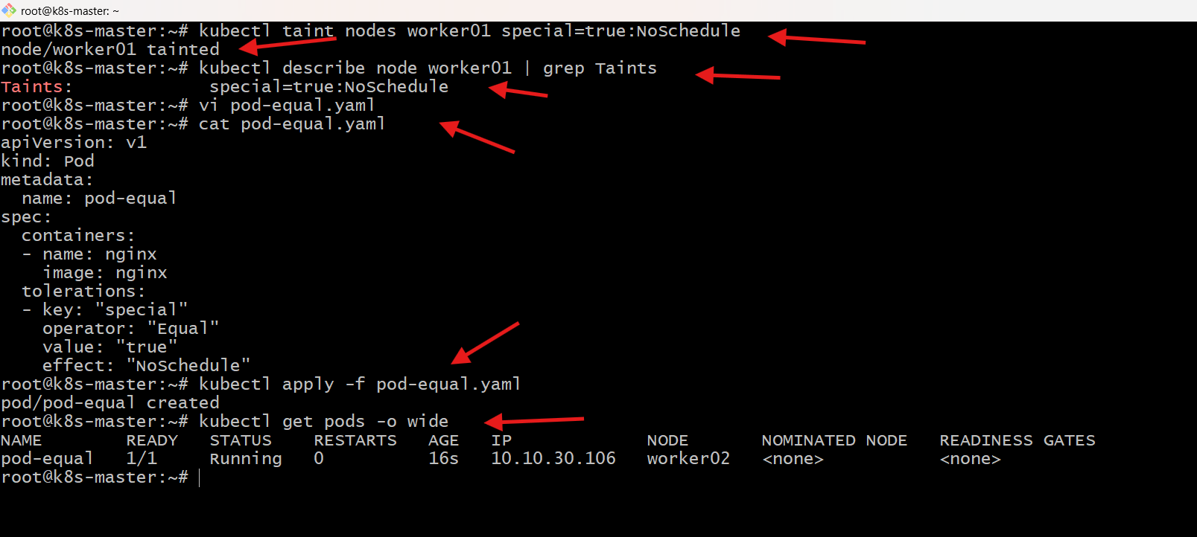
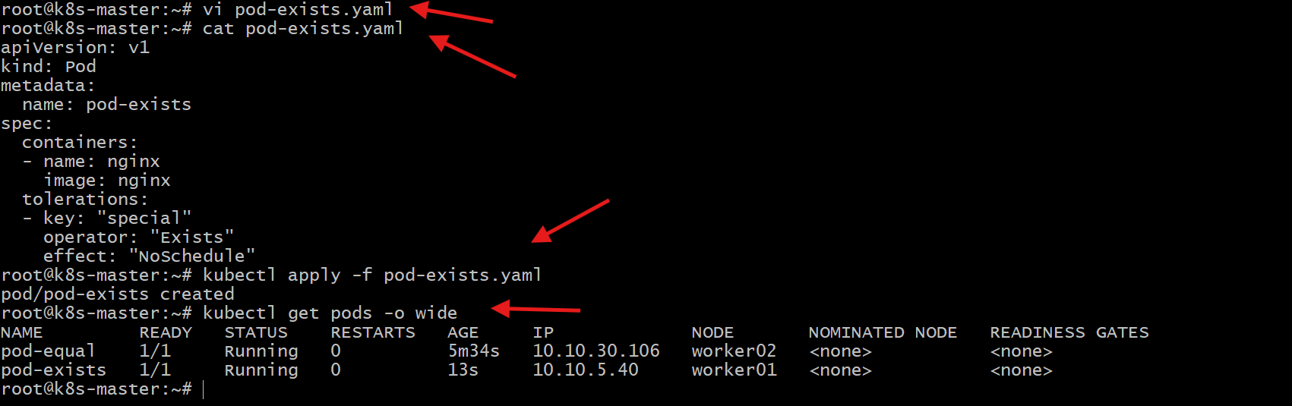
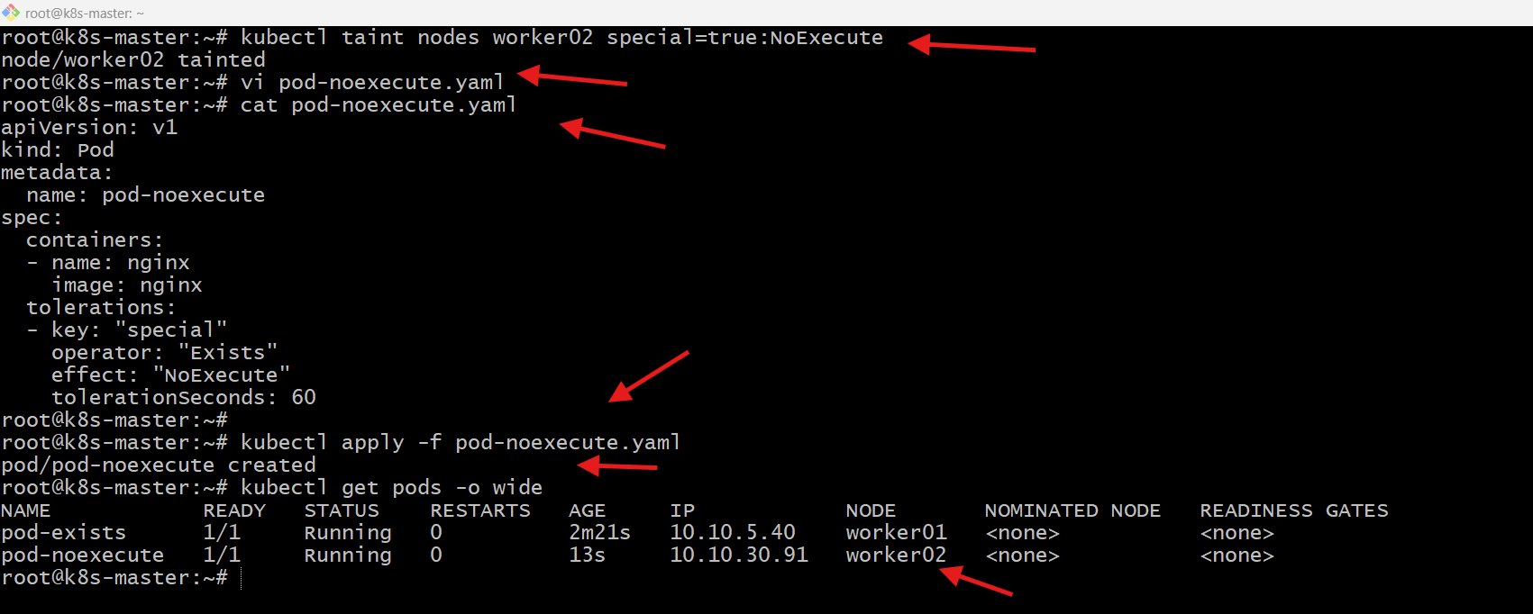
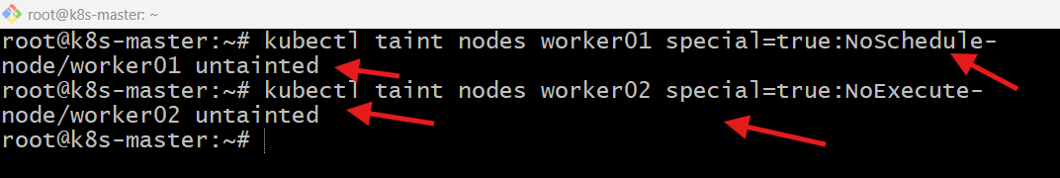
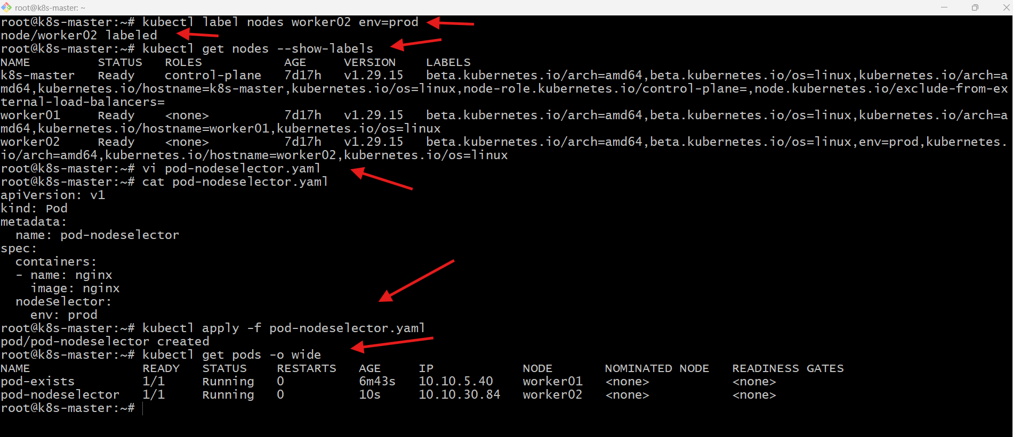
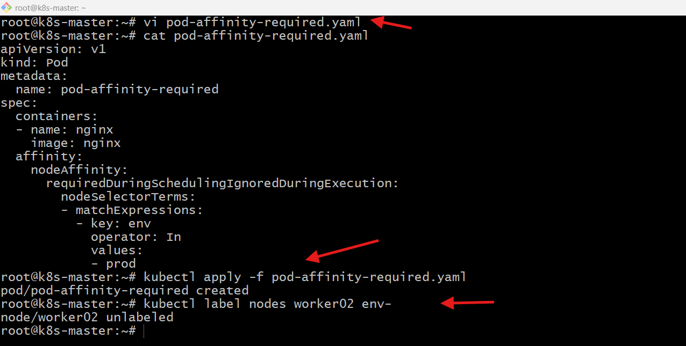

Task 2: Taint a Node and Schedule a Tolerant Pod Taint a node with special=true:NoSchedule. Create a pod with a toleration that matches the taint, allowing it to be scheduled on the tainted node.
Steps Performed:
Taint a Node and Schedule a Tolerant Pod
Checked available nodes
kubectl get nodes
Confirmed nodes: k8s-master, worker01, worker02.
Applied taint on worker01
kubectl taint nodes worker01 special=true:NoSchedule
Taint successfully applied.
Verified taint
kubectl describe node worker01 | grep Taints
Observed:
special=true:NoSchedule
Created test pod (without toleration)
Created test-pod.yaml using nginx container.
kubectl apply -f test-pod.yaml
Pod created.
Checked pod scheduling
kubectl get pods -o wide
Pod scheduled on worker02, not worker01.
Reason: worker01 is tainted → pod has no toleration.
Created tolerant pod
Created tolerant-pod.yaml with toleration:
• key = special
• operator = Equal
• value = true
• effect = NoSchedule
Applied tolerant pod
kubectl apply -f tolerant-pod.yaml
Pod created successfully.
Verified scheduling
kubectl get pods -o wide
tolerant-pod scheduled on worker01.
Reason: toleration matches taint → scheduler allowed placement.
Observed behaviour
• Normal pod → avoided tainted node
• Tolerant pod → scheduled on tainted node
Demonstrates correct taint & toleration mechanism.
Command to Untainted: kubectl taint nodes worker01 special=true: NoSchedule-

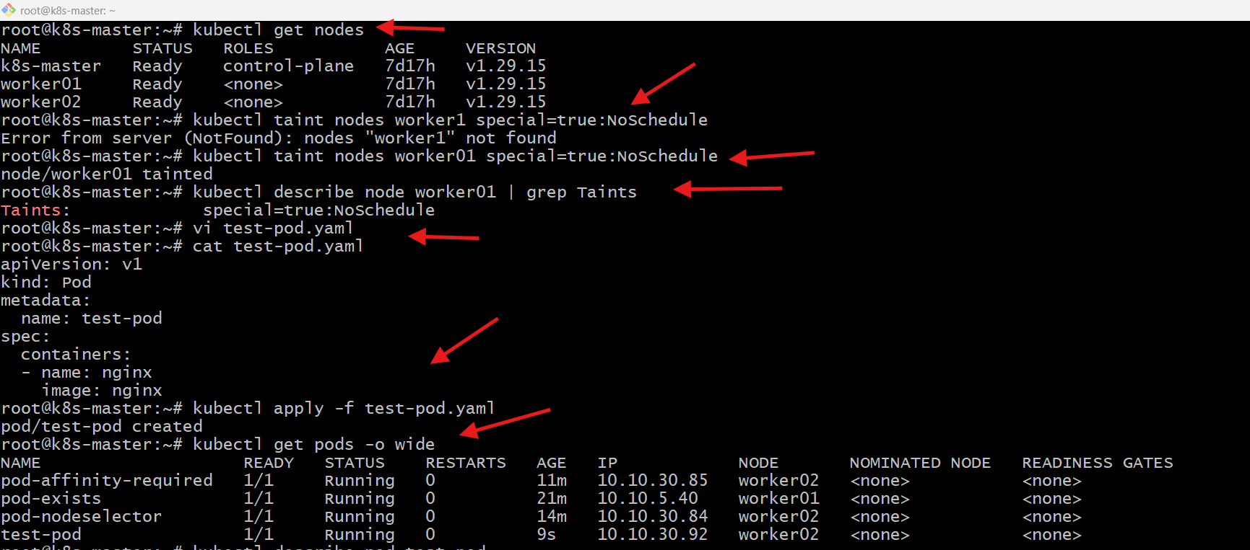
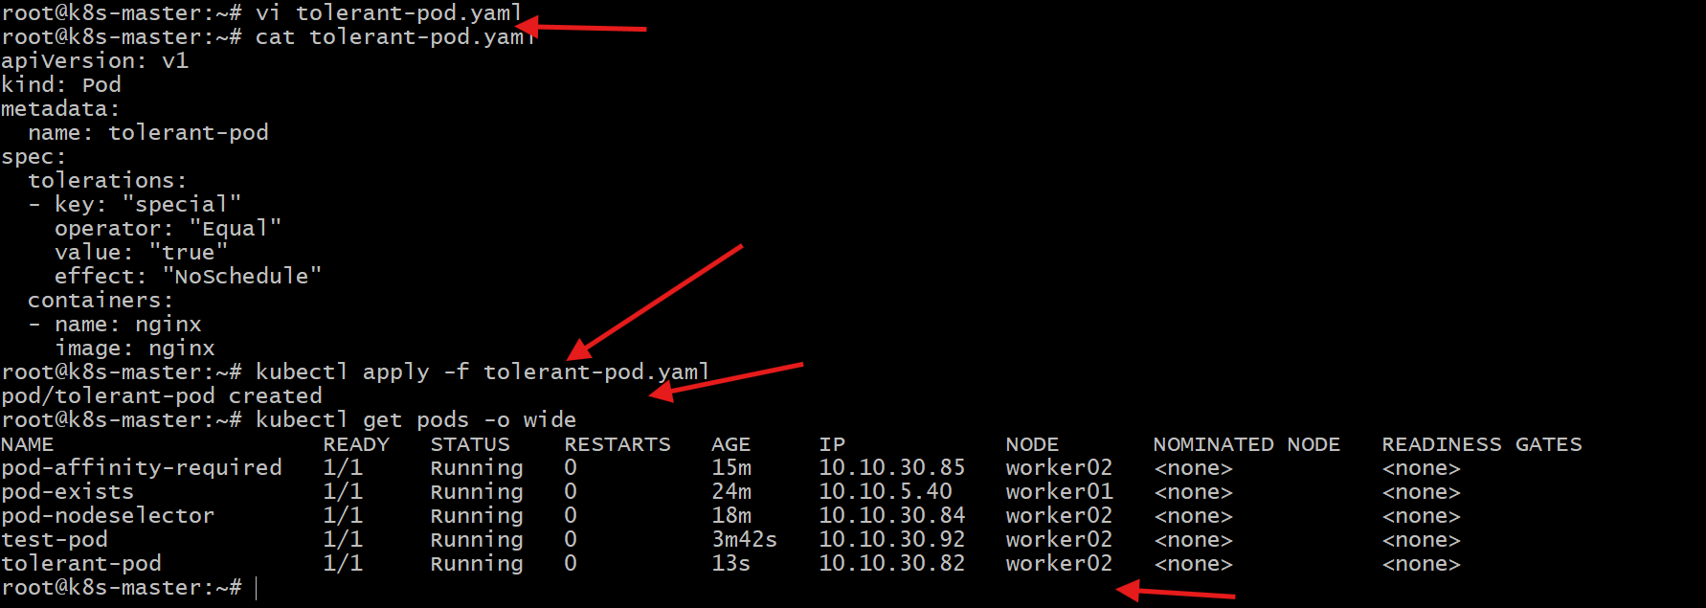

Task 3: Use NodeSelector to Schedule a Pod on a Specific Node Label a node with env=dev. Create a pod with a nodeSelector that schedules it only on the node labeled env=dev.
Steps Performed:
Use NodeSelector to Schedule Pod on Specific Node
Checked nodes
kubectl get nodes
Verified available nodes: k8s-master, worker01, worker02.
Attempted labeling incorrect node name
kubectl label nodes worker1 env=dev
Error received:
nodes "worker1" not found
Reason: incorrect node name.
Applied label on correct node
kubectl label nodes worker01 env=dev
Label successfully applied.
Verified node labels
kubectl get nodes --show-labels
Observed worker01 contains:
env=dev
Created pod definition
Created dev-pod.yaml with NodeSelector:
• env = dev
Pod uses nginx container.
Applied pod
kubectl apply -f dev-pod.yaml
Pod created successfully.
Verified scheduling
kubectl get pods -o wide
dev-pod scheduled on worker01.
Reason: NodeSelector matched node label.
Observed behavior
NodeSelector forces pod placement strictly based on labels.
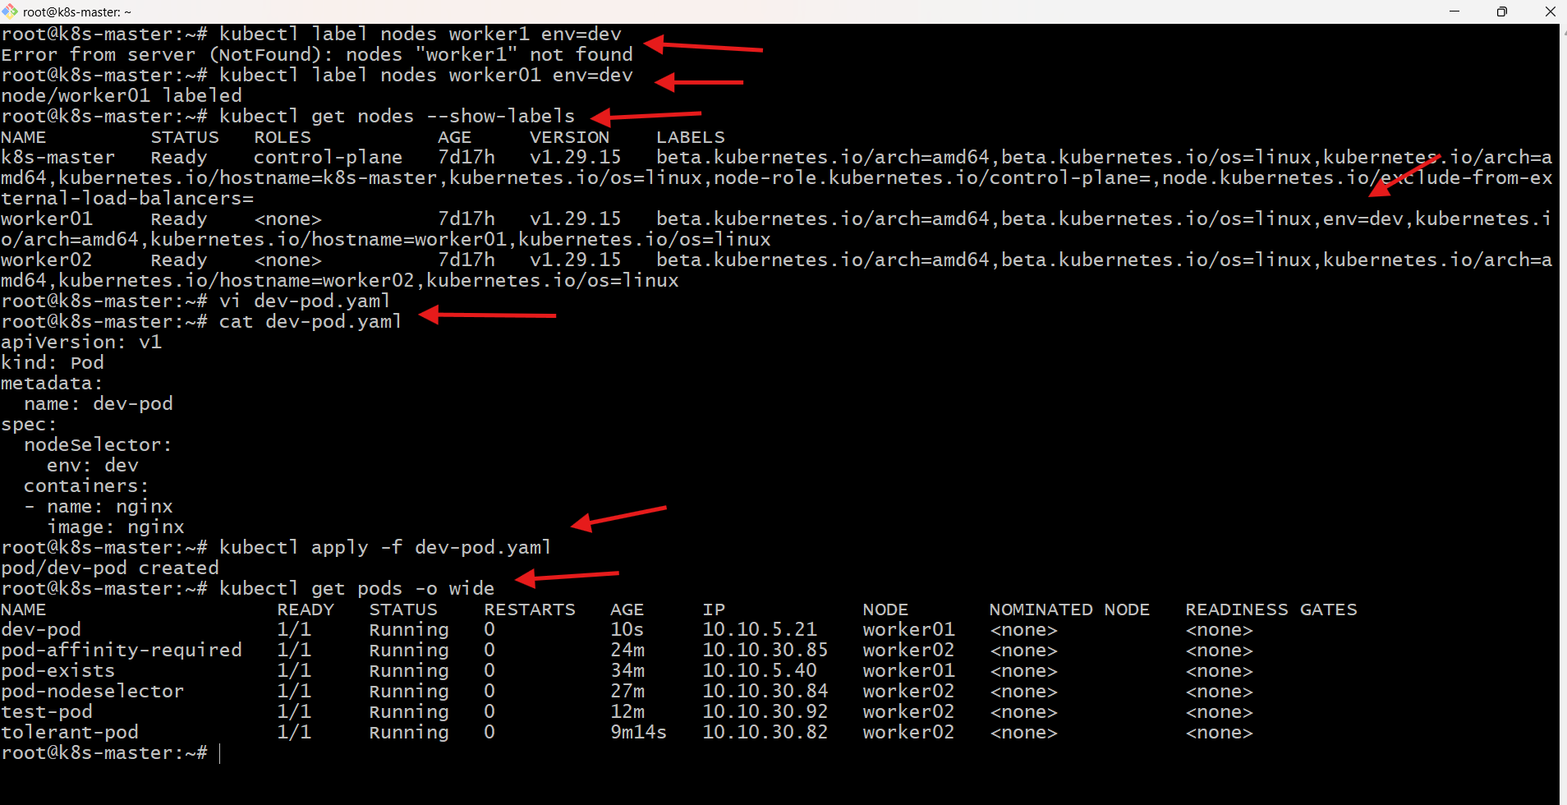

Task 4: Use Node Affinity with Soft Scheduling Label a node with env=test. Create a pod with PreferredDuringSchedulingIgnoredDuringExecution node affinity, preferring to schedule it on a node labeled env=test. Remove the label and verify the pod continues to run.
Steps performed:
Use Node Affinity with Soft Scheduling
Applied label on worker02
kubectl label nodes worker02 env=test
Label successfully applied.
Verified node labels
kubectl get nodes --show-labels
Confirmed worker02 contains:
env=test
Created pod definition
Created soft-affinity-pod.yaml with:
Node Affinity → preferredDuringSchedulingIgnoredDuringExecution
Configuration:
• key = env
• operator = In
• values = test
• weight = 1
Container: nginx
Applied pod
kubectl apply -f soft-affinity-pod.yaml
Pod created successfully.
Verified pod scheduling
kubectl get pods -o wide
soft-affinity-pod scheduled on worker02.
Reason: scheduler preferred node matching affinity rule.
Removed node label
kubectl label nodes worker02 env-
Label successfully removed.
Verified labels removal
kubectl get nodes --show-labels
Confirmed env=test label no longer present.
Checked pod status
kubectl get pods -o wide
soft-affinity-pod continues Running.
Reason:
preferredDuringSchedulingIgnoredDuringExecution = Soft Rule
• Affects scheduling decision only
• Ignored during execution
Observed behavior
• Pod preferred labeled node
• Label removed → Pod not evicted
• Pod continues running normally
Demonstrates soft affinity behavior.
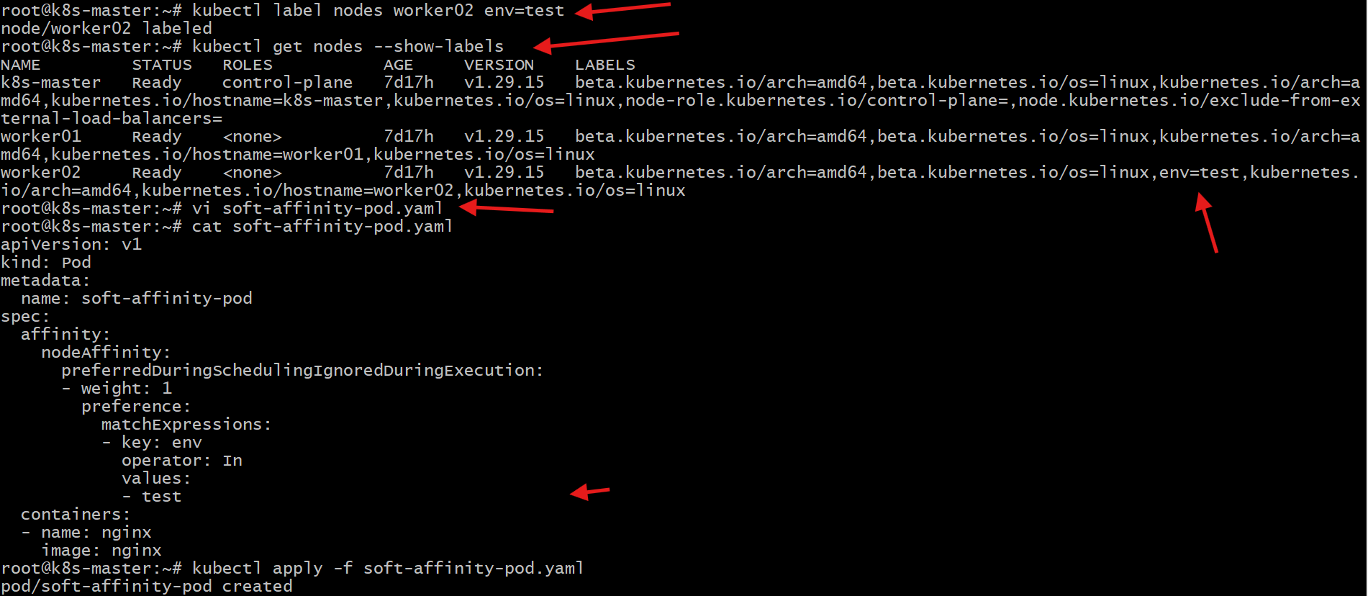
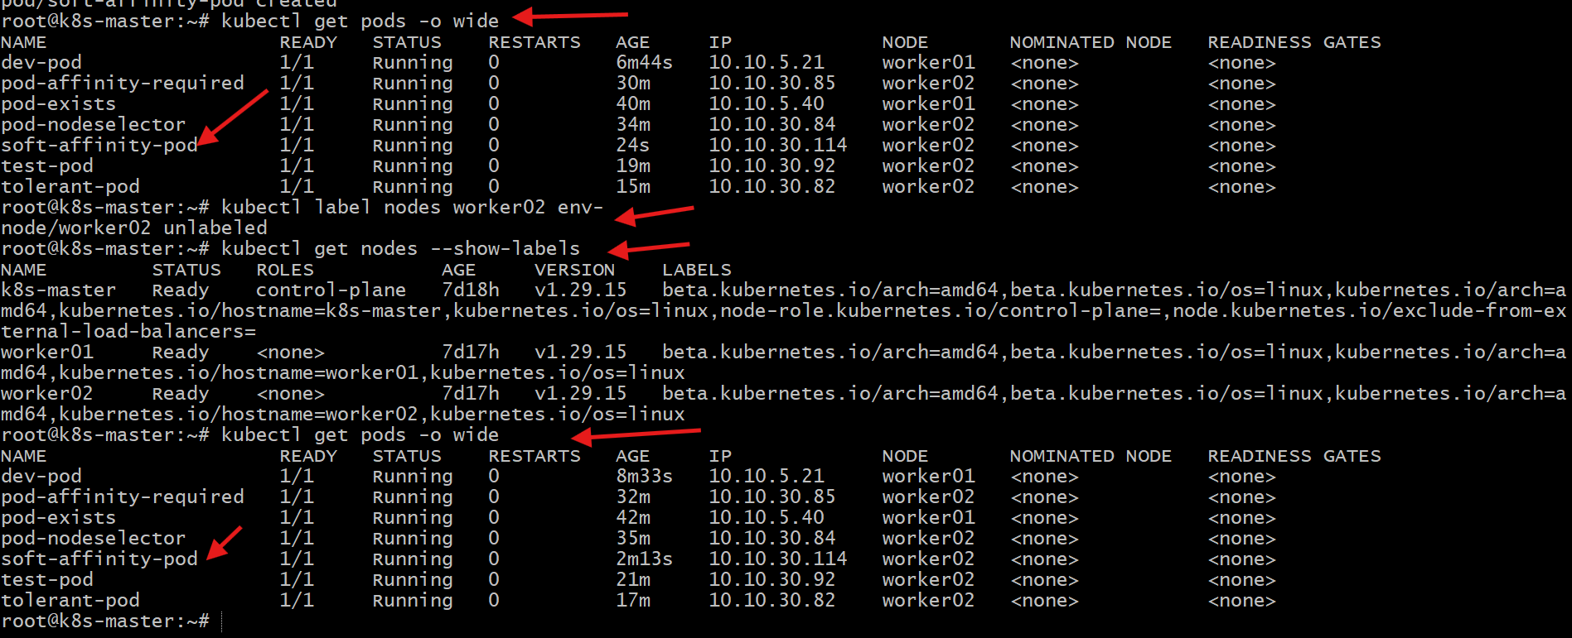

Task 5: Implement Node Affinity with Hard Scheduling Create a pod with RequiredDuringSchedulingIgnoredDuringExecution node affinity, ensuring it will only be scheduled on a node labelled env=prod. Verify the pod cannot be scheduled if no node has the env=prod label.
Steps Performed:
Implement Node Affinity with Hard Scheduling
Verified node labels
kubectl get nodes --show-labels
Observed no node initially had the label:
env=prod
Created pod definition
Created hard-affinity-pod.yaml with:
Node Affinity → requiredDuringSchedulingIgnoredDuringExecution
Configuration:
• key = env
• operator = In
• values = prod
Container: nginx
Applied pod
kubectl apply -f hard-affinity-pod.yaml
Pod created successfully.
Checked pod status
kubectl get pods
hard-affinity-pod → Pending
Reason: No node matched affinity rule.
Diagnosed scheduling issue
kubectl describe pod hard-affinity-pod
Observed scheduler message:
• 0/3 nodes available
• Nodes didn’t match pod’s node affinity/selector
Confirms affinity constraint blocked scheduling.
Applied required label
kubectl label nodes worker02 env=prod
Label successfully applied.
Verified labels
kubectl get nodes --show-labels
Confirmed worker02 contains:
env=prod
Checked pod scheduling
kubectl get pods -o wide
hard-affinity-pod → Running
Scheduled on worker02
Reason: Node now satisfies hard affinity rule.
Observed behavior
• Hard affinity strictly enforced
• No matching node → Pod Pending
• Matching node added → Pod Scheduled
Demonstrates requiredDuringScheduling behavior.
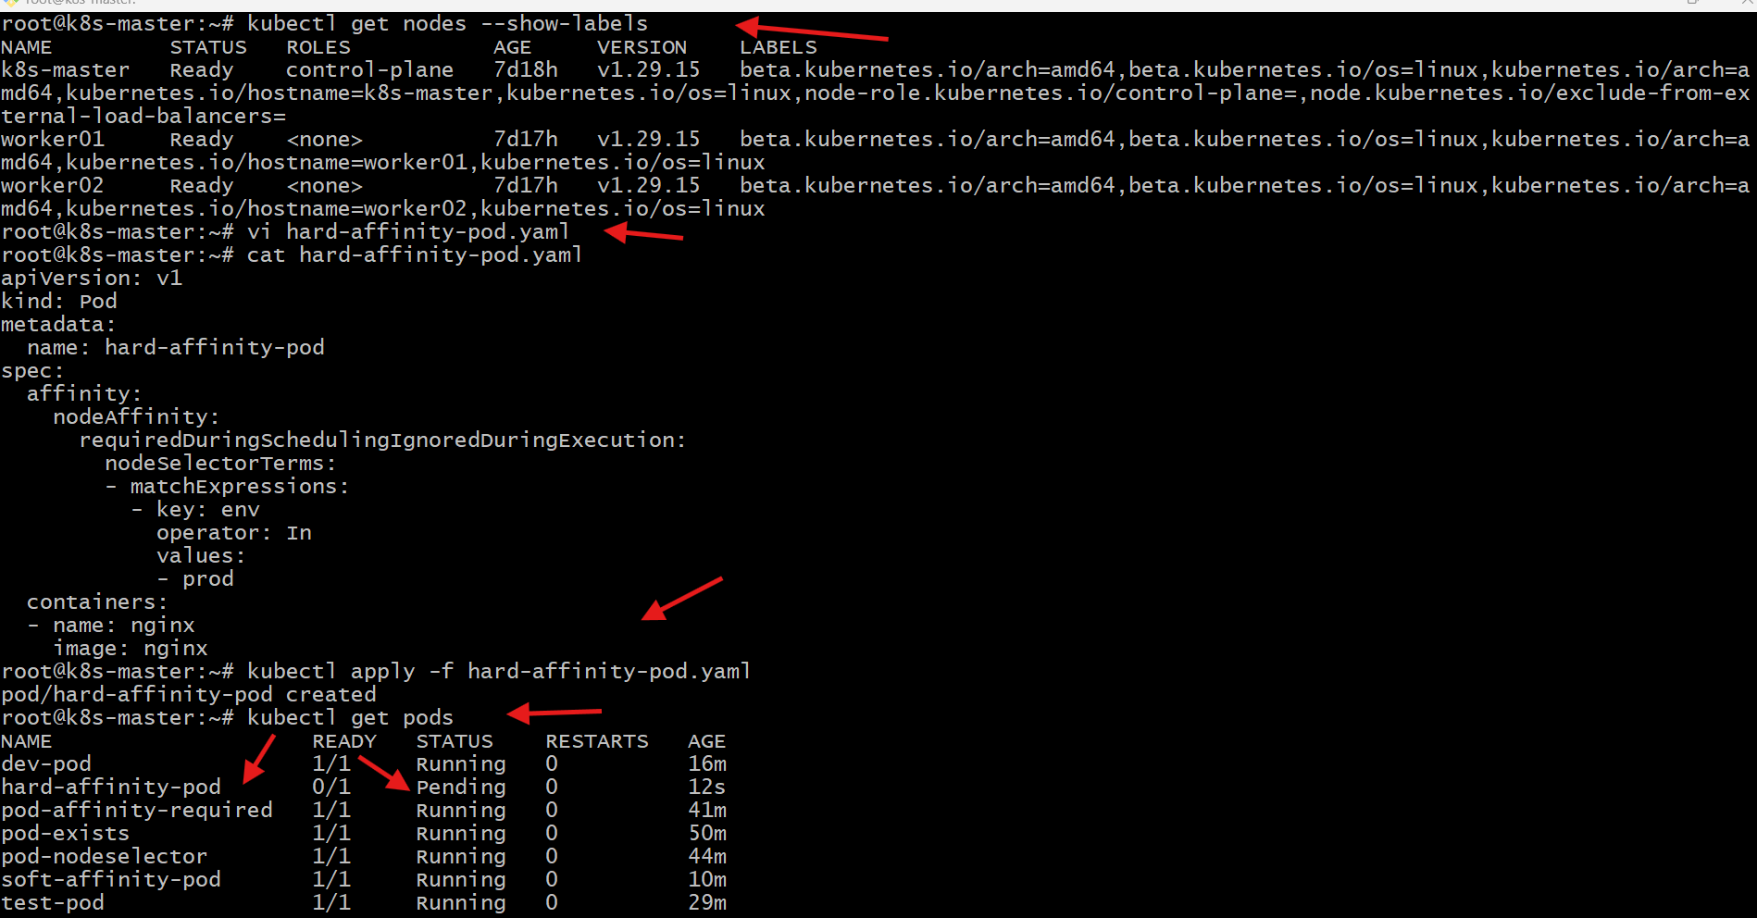
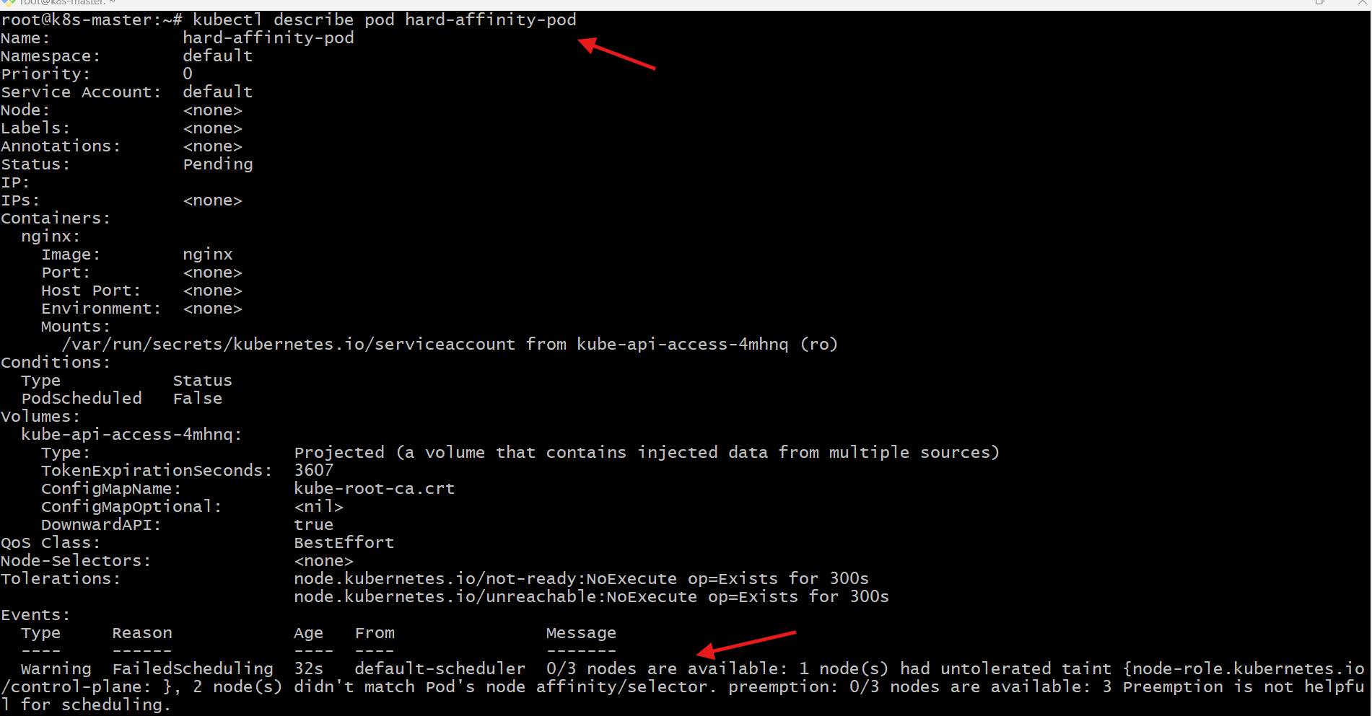
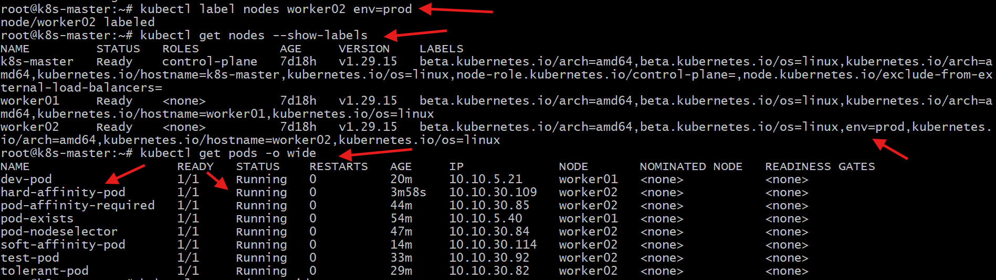

Task 6: Taint a Node and Use NoExecute with Toleration Seconds Taint a node with special=true:NoExecute. Create a pod with a tolerationSeconds field (e.g., 60 seconds) and observe it gets evicted after 60 seconds on the tainted node.
Steps Performed:
Taint Node and Use NoExecute with TolerationSeconds
Applied NoExecute taint on worker01
kubectl taint nodes worker01 special=true:NoExecute
Taint successfully applied.
Verified taint
kubectl describe node worker01 | grep Taints
Observed:
special=true:NoExecute
Created pod definition
Created noexecute-pod.yaml with toleration:
• key = special
• operator = Equal
• value = true
• effect = NoExecute
• tolerationSeconds = 60
Container: nginx
Applied pod
kubectl apply -f noexecute-pod.yaml
Pod created successfully.
Verified pod scheduling
kubectl get pods -o wide
noexecute-pod scheduled on worker01.
Reason: toleration matches taint.
Observed pod behavior
kubectl get pods
Initially:
noexecute-pod → Running
Waited for toleration timeout
After ~60 seconds:
kubectl get pods
noexecute-pod → No longer present
Verified eviction
kubectl describe pod noexecute-pod
Error received:
pod not found
Reason:
Pod evicted automatically after tolerationSeconds expired.
Observed behaviour
• NoExecute taint → triggers eviction logic
• tolerationSeconds → temporary tolerance
• Timeout reached → Pod removed
Demonstrates eviction mechanism of NoExecute taints.
